Preview of table before normalization:

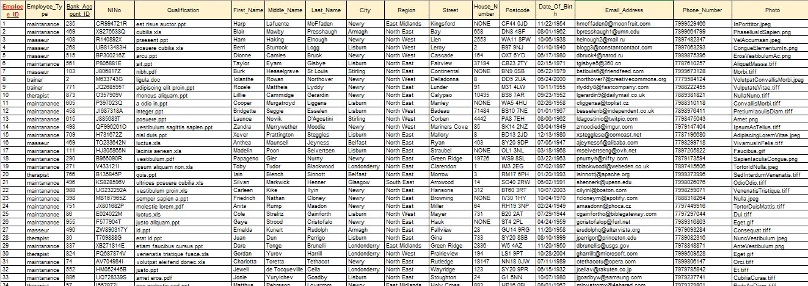

1NF

PK is attribute employee_ID.

FK is bank_account_ID.

Attributes city, region, street_name, house_number and postcode will be separate in entity employees_adresses. In table employee will be add attribute employee_address_ID.

Attribute employee_type will be switch with employee_type_ID, and remove in to entity employee_types.

Attribute qualification will be moved in entity employee_types.

Preview of table after 1NF:

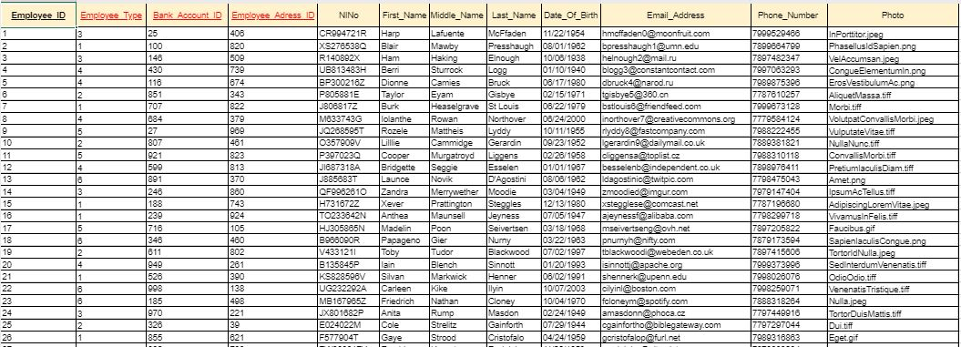

2NF

All attributes depend on PK. Table is in 2NF.

3NF

There is none transitive dependencies.